# **EXPERIMENT NO : 12**

# **AIM** :- To understand AWS lambda and its workflow.

# **THEORY:-**

# **Title**: **Serverless at Scale: Transforming E-commerce with AWS Lambda**

# **Background:-**

# E-commerce company "Shopazon" was experiencing rapid growth in its online business, with thousands of products and millions of customers. The company's traditional monolithic architecture was struggling to keep up with this demand, leading to slow response times, frequent downtime, and difficulties in scaling during peak traffic periods.

**Architecture:-**

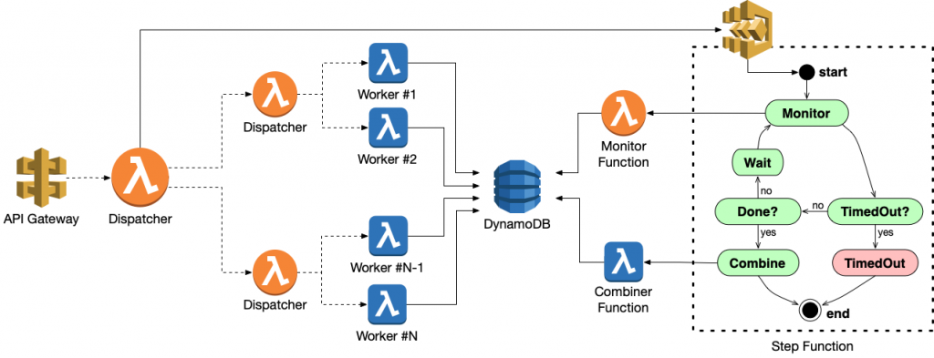

# **Challenges:-**

# **Scalability:** Shopazon needed a system that could handle fluctuating workloads, especially during peak shopping seasons.

# **Response Time:** Slow response times were affecting the user experience, leading to cart abandonment and loss of sales.

# **Cost Efficiency:** Maintaining large, underutilized server fleets was costly and inefficient.

# **Developer Productivity:** Developers wanted to focus on writing code rather than managing infrastructure.

# **Solution:**

# Shopazon decided to embrace serverless computing and adopted AWS Lambda as a core component of their architecture. They developed a solution that utilized AWS Lambda to handle various parts of their system, including order processing, image resizing, authentication, and more.

# **Order Processing**:

# When a customer places an order on the Shopazon website, a Lambda function is triggered by an S3 bucket event.

# The Lambda function processes the order, calculates taxes and shipping costs, and stores the order details in a database.

# The function also sends an email confirmation to the customer using Amazon Simple Email Service (SES).

# **Image Resizing**:

# Product images uploaded by vendors are stored in an S3 bucket.

# Whenever a new image is uploaded, a Lambda function is triggered.

# The Lambda function resizes the image into multiple sizes to optimize for different devices (thumbnail, mobile, desktop) and stores them back in the S3 bucket.

# **Authentication**:

# Shopazon uses Amazon Cognito for user authentication.

# When a user signs up or logs in, a Lambda function is triggered to handle the authentication process.

# The function interacts with Cognito, generates and validates tokens, and authorizes users.

# **Monitoring and Logging**:

# AWS CloudWatch and AWS X-Ray are used to monitor and trace Lambda functions.

# Logs are sent to Amazon CloudWatch Logs for real-time analysis and debugging.

# **Benefits:-**

# **Scalability**: With AWS Lambda, Shopazon can automatically scale its functions in response to incoming traffic, ensuring a smooth shopping experience during peak seasons.

# **Improved Response Times**: Serverless architecture reduces the time needed to provision and manage servers, leading to faster response times for customers.

# **Cost Efficiency**: Shopazon only pays for the compute time used by their Lambda functions, eliminating the need to maintain a large server fleet and reducing operational costs.

# **Developer Productivity**: Developers can focus on writing code and building features, as AWS Lambda abstracts the underlying infrastructure management.

# 

# **Conclusion:-**

# By adopting AWS Lambda and a serverless architecture, Shopazon transformed its e-commerce platform. It now provides a highly scalable, cost-effective, and responsive shopping experience for its customers while allowing its development teams to be more productive and agile in delivering new features and improvements. Serverless with AWS Lambda has played a crucial role in helping Shopazon succeed in the highly competitive e-commerce industry.